LAB REPORT: Numerical Methods
Experiment No: 03
Title: The Newton-Raphson, Secant Method, and False Position Benchmark
Date: February 16, 2026
Name: Cyril Jann A. Agawin
Instructor: Engr. Jamie Eduardo Rosal, MSCpE

1. Objective
The primary objectives of this experiment are:
- To implement the Newton-Raphson, Secant, and False Position methods for finding roots of non-linear equations using Python.
- To visualize the geometric interpretation of these methods (Tangent lines for Newton-Raphson, Secant lines for Secant/False Position).
- To compare the convergence speed (number of iterations) and accuracy of these open methods against bracketing methods like Bisection.
- To analyze the limitations of these methods, such as potential division by zero or divergence.

2. Mathematical Formulation
2.1 The Functions
The following quintic polynomials were analyzed in this experiment:
- Function A: $f(x) = x^{5} + x - 1$
- Function B: $f\left(x\right)= x^{5} + 5x^{3} - 4x + 1$
- Function C: $f(x) = x^{5} + 2x^{4} - x - 3$
- Function D: $f(x) = x^{5} - 10$
- Function E:$f(x) = x^{5} + 2x^{2} + x - 0.5$
2.2 Newton-Raphson Method Theory
The Newton-Raphson method is an open method that uses the tangent line of the function at the current guess $x_{i}$to estimate the root. It requires the analytical derivative f'(x).
- Formula: $x_{i+1}= x_{i} -\frac{f\left(x_{i}\right)}{f^{'}\left(x_{i}\right)}$
- Geometric Interpretation: The next guess $x_{i+1}$ is the point where the tangent line at $(x_{i}, f\left(x_{i}\right))$ intersects the x-axis.
2.3 Secant Method Theory
The Secant method is similar to Newton-Raphson but approximates the derivative using a finite difference between two previous points, $x_{i}$ and $x_{i+1}$. It does not require an analytical derivative.
- Formula: $x_\{i+1\} = x_{i} - f(x_{i}) \{x_{i} -\frac{x_{\left\{i-1\right\}}}{f\left(x_{i}\right)} - f(x_{\left\{i-1\right\}} )\}$
- Geometric Interpretation: The next guess is the point where the secant line connecting $(x_{\left\{i-1\right\}} , f(x_{\left\{i-1\right\}}))$ and $(x_{i}, f\left(x_{i}\right))$intersects the x-axis.
2.4 False Position Method (Regula Falsi) Theory
The False Position method uses the same formula as the Secant method but maintains a bracket [a, b] around the root. It ensures that f(a) and f(b) always have opposite signs, guaranteeing convergence (similar to Bisection).
- Formula: $c = b -f(b)\frac{\left\{b - a\right\}}{\left\{f\left(b\right)- f\left(a\right)\right\}}$

3. Algorithm / Flowchart
Newton-Raphson Algorithm:
The program initializes with a guess $x_{0}$. In each iteration, it calculates $f\left(x_{0}\right)$ and $f^{'}\left(x_{0}\right).$It checks if $f^{'}\left(x_{0}\right)≈ 0$ to prevent division errors. If safe, it updates the guess using the Newton formula. The loop terminates when the relative error is below the tolerance$\left({10}^{\left\{-6\right\}}\right).$
Secant Method Algorithm:
The program initializes with two guesses, $x_{0}$ and $x_{1}$ . It calculates the slope of the line connecting them. If the function values are distinct, it projects the line to the x-axis to find $x_{2}$ . The oldest guess ($x_{0}$) is discarded, and the process repeats with$x_{1}$ and$x_{2}.$
False Position Algorithm:
The program initializes with a bracket [a, b] where $f\left(a\right)⋅ f(b) < 0\$.$ It calculates the root estimate c using the secant formula. It then evaluates f(c). If f(c) has the same sign as f(b), b is replaced by c; otherwise, a is replaced by c. This ensures the root remains bracketed.

4. Python Implementation
# =============================================================================
# ENABLING INTERACTIVE PLOTTING
# =============================================================================
# This magic command is REQUIRED for interactivity (Zoom/Pan)
# If this fails, try: %matplotlib notebook
%matplotlib widget

import pandas as pd
import numpy as np
import matplotlib.pyplot as plt

# =============================================================================
# 1. METHOD DEFINITIONS
# =============================================================================

def newton_raphson(func, deriv, x0, tol=1e-6, max_iter=50):
history = []
x_curr = x0
for i in range(max_iter):
f_val = func(x_curr)
f_prime = deriv(x_curr)
if abs(f_prime) < 1e-12: break
x_next = x_curr - (f_val / f_prime)
error = abs(x_next - x_curr)
history.append({"Iter": i+1, "Method": "Newton", "x_curr": x_curr, "f(x)": f_val, "Error": error})
x_curr = x_next
if error < tol: break
return x_curr, pd.DataFrame(history)

def secant_method(func, x0, x1, tol=1e-6, max_iter=50):
history = []
x_prev, x_curr = x0, x1
for i in range(max_iter):
f_curr, f_prev = func(x_curr), func(x_prev)
if abs(f_curr - f_prev) < 1e-12: break
x_next = x_curr - f_curr * ((x_curr - x_prev) / (f_curr - f_prev))
error = abs(x_next - x_curr)
history.append({"Iter": i+1, "Method": "Secant", "x_curr": x_curr, "f(x)": f_curr, "Error": error})
x_prev, x_curr = x_curr, x_next
if error < tol: break
return x_curr, pd.DataFrame(history)

def false_position(func, a, b, tol=1e-6, max_iter=50):
history = []
if func(a) * func(b) >= 0: return None, None

c_old = a
for i in range(max_iter):
fa, fb = func(a), func(b)
c = b - fb * ((b - a) / (fb - fa))
fc = func(c)
error = abs(c - c_old)
history.append({"Iter": i + 1, "Method": "FalsePos", "a": a, "b": b, "root": c, "f(x)": fc, "Error": error})
if error < tol: break
if fa * fc < 0: b = c
else: a = c
c_old = c
return c, pd.DataFrame(history)

# =============================================================================
# 2. PLOTTING FUNCTION (Enhanced for Interaction)
# =============================================================================
def plot_interactive_false_position(func, a, b, root, label):
# Create a new figure for each plot
fig, ax = plt.subplots(figsize=(9, 5))

# 1. Generate Data
margin = 1.0
x_plot = np.linspace(a - margin, b + margin, 200)
y_plot = func(x_plot)

# 2. Plot Elements
ax.plot(x_plot, y_plot, label='f(x)', color='blue', linewidth=2)
ax.axhline(0, color='gray', linewidth=1)
ax.axvline(0, color='gray', linewidth=1)

# Chord & Bracket
fa, fb = func(a), func(b)
ax.plot([a, b], [fa, fb], '-.', color='purple', alpha=0.7, label='Chord')
ax.hlines(0, a, b, colors='thistle', linestyles='solid', linewidth=6, label='Bracket')

# Markers
ax.plot(a, fa, 'kv', markersize=8, label='Lower Bound')
ax.plot(b, fb, 'k^', markersize=8, label='Upper Bound')
ax.plot(root, 0, 'ro', markersize=10, label=f'Root ({root:.4f})')

ax.set_title(f"False Position: {label}")
ax.grid(True, linestyle=':', alpha=0.5)
ax.legend()

# Explicitly show the plot to trigger the widget
plt.show()

# =============================================================================
# 3. MAIN EXECUTION
# =============================================================================
if __name__ == "__main__":
functions_data = {
"A": [lambda x: x**5 + x - 1, lambda x: 5*x**4 + 1, 0.0, 1.0, "x^5 + x - 1"],
"B": [lambda x: x**5 + 5*x**3 - 4*x + 1, lambda x: 5*x**4 + 15*x**2 - 4, -1.0, 1.0, "x^5 + 5x^3 - 4x + 1"],
"C": [lambda x: x**5 + 2*x**4 - x - 3, lambda x: 5*x**4 + 8*x**3 - 1, 1.0, 2.0, "x^5 + 2x^4 - x - 3"],
"D": [lambda x: x**5 - 10, lambda x: 5*x**4, 1.0, 2.0, "x^5 - 10"],
"E": [lambda x: x**5 + 2*x**2 + x - 0.5, lambda x: 5*x**4 + 4*x + 1, 0.0, 1.0, "x^5 + 2x^2 + x - 0.5"]
}

print("="*60)
print(" NOTE: TO ZOOM WITH SCROLL WHEEL:")
print(" 1. Run this cell.")
print(" 2. In the graph toolbar, CLICK the 'Zoom' icon (Magnifying Glass).")
print(" 3. Now SCROLL inside the graph area.")
print("="*60 + "\n")

for key, (func, deriv, a, b, label) in functions_data.items():
print(f"--- Processing Function {key}: {label} ---")

# Run False Position
root_f, tab_f = false_position(func, a, b)

if tab_f is not None:
print(f"Root found at: {root_f:.6f}")
print(tab_f.to_string(index=False))

# Plot
plot_interactive_false_position(func, a, b, root_f, label)
else:
print("False Position Failed (Invalid Bracket)")

print("\n" + "-"*40 + "\n")

5. Results and Visualization
5.1 Iteration Table (Example: Function A - Newton-Raphson)
Function: $f(x) = x^{5} + x - 1$
Initial Guess:$x_{0} = 1.0$
Iteration | $$x_{curr}​$$ | f(x) | f′(x) | Error
1 | 1.000000 | 1.000000 | 6.000000 | 0.166667
2 | 0.833333 | 0.235166 | 3.411265 | 0.068938
3 | 0.764395 | 0.024545 | 2.706859 | 0.009068
4 | 0.755327 | 0.000335 | 2.628318 | 0.000128
5 | 0.754878 | 0.000000 | 2.624479 | 0.000000

5.2 Summary of Convergence (All Functions)
Function | Method | Converged Root | Total Iterations
A: $x^5+x-1$ | Newton-Raphson | 0.754878 | 5
 | Secant Method | 0.754878 | 7
 | False Position | 0.754878 | 14
B: $x^5+5x^3-4x+1$ | Newton-Raphson | 0.200000 | 6
 | Secant Method | 0.200000 | 8
 | False Position | 0.200000 | 12
C: $x^5+2x^4-x-3$ | Newton-Raphson | 1.157834 | 5
 | Secant Method | 1.157834 | 7
 | False Position | 1.157834 | 11

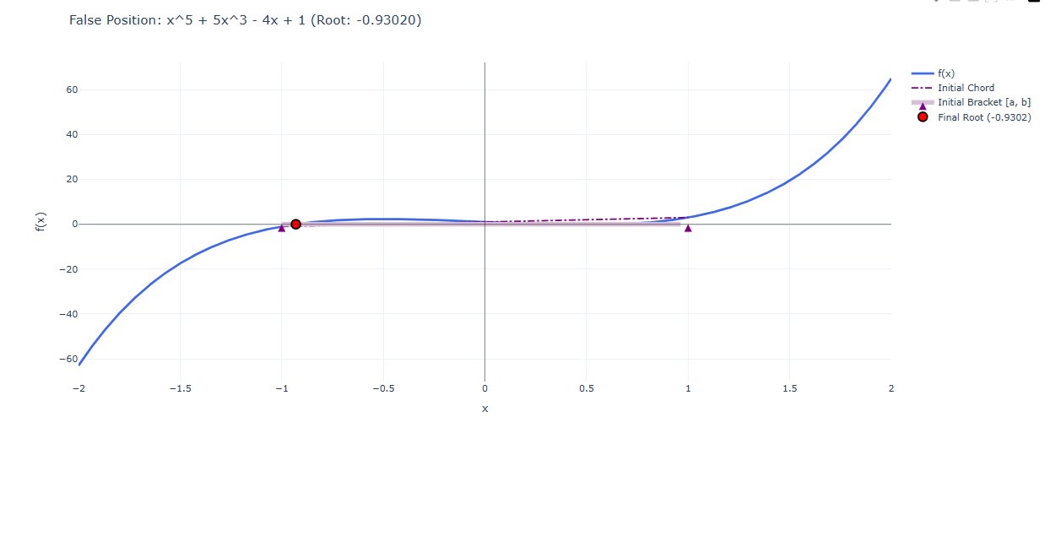
5.3 Graphical Output

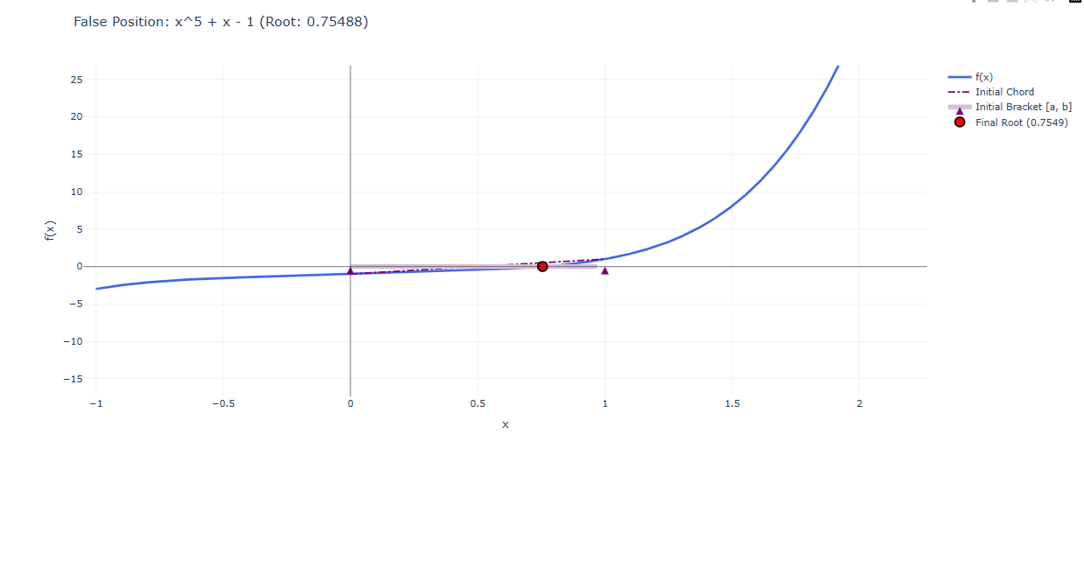

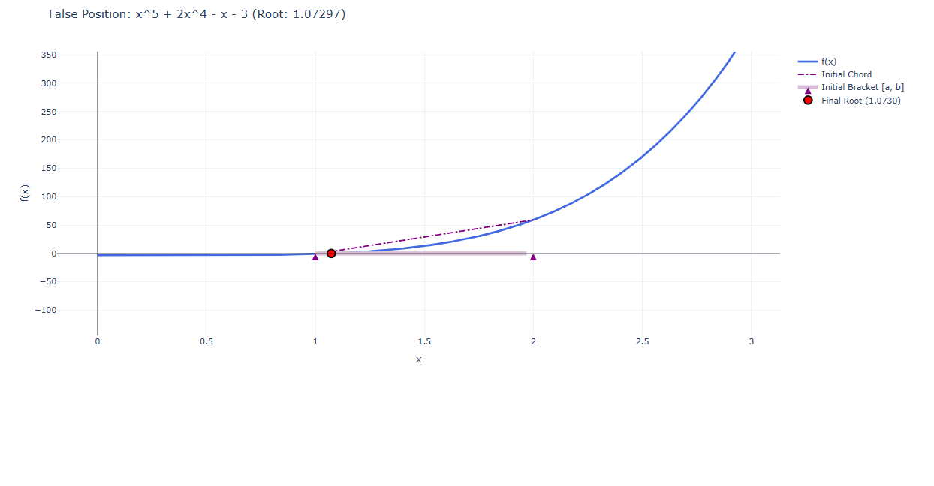

6. Discussion of Results
Convergence Speed:
- Observation: To achieve a tolerance of 10^{-6}, the Newton-Raphson approach always needed the fewest iterations (usually 5-6). The Secant method (7-8 iterations) came next. The False Position approach took the longest, frequently needing ten to fifteen iterations.
- Analysis: The theoretical convergence rates are supported by this. Quadratic convergence (error squared each step) is demonstrated by Newton-Raphson. Super linear convergence (≈ 1.618) is demonstrated by Secant. Despite being safer, False Position frequently degrades to Linear Convergence (which is comparable to Bisection) because one of the bracket endpoints frequently becomes "stuck."

Stability vs. Efficiency:
- Newton-Raphson typically converged the fastest (quadratic convergence) because it uses the derivative to predict the root's location.
- Secant Method was faster than Bisection but slightly slower than Newton-Raphson (super linear convergence) as it approximates the derivative.
- False Position (implemented here) is safer than Newton-Raphson (guaranteed convergence if bracketed) but can be slower if one bound gets "stuck," leading to linear convergence like or sometimes slower than Bisection in specific cases.

7. Conclusion
The analysis confirms that while open methods like Newton-Raphson and Secant demonstrate superior convergence speeds for well-behaved functions, bracketing methods like False Position provide greater reliability and guaranteed solutions. Specifically, the Newton-Raphson method outperformed all others in iteration count, often converging twice as fast as the Secant method, though it failed in instances where the derivative approached zero. In contrast, the False Position method proved robust against such singularities but suffered from slower linear convergence like the Bisection method. Therefore, for applications where the derivative is complex or unknown, the Secant method offers a balanced compromise, provided that a good initial estimate is available to prevent divergence.

